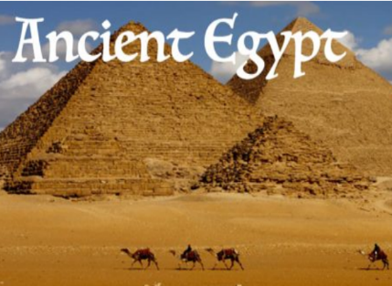

Cornets and Trumpets Information leaflet Summer 2

2024/2025

**English**— The children will be reading ‘Zeraffa Giraffa’ by Diane Hoffmeyer. This is a true story about a giraffe who travels from Egypt to France. The children will work on building different sentence structures, using tenses correctly and using organisational features. They are working towards writing a persuasive guide for visiting Zeraffa at the Jardin des Plantes in Paris.

**Maths** – We will be learning about time. This will be telling the time to the nearest minute, using ‘a.m.’ and ‘p.m.’ to describe the time of day and 24-hour clock. We will be learning more about fractions including equivalent fractions, ordering and comparing fractions and also adding and subtracting fractions.

**Science**-This term we will be learning about plants; we will be looking at functions of different parts of flowering plants and also explore what plants need for life and growth. We will also be investigating how water is transported within plants.

**Art/DT**— The children will produce nature art work inspired Andy Goldsworthy

**Music** - Recorders/Singing –We will be continuing with our recorder playing and develop our skills in playing simple tunes, reading notation and composing. They will be listening to a range of different genres of music including ‘Walk like an Egyptian’.

**P.E/Games**— Athletics and Rounders

**French**- This term we will celebrate diversity day with a Café de l’ecole (french café). The children will also be learning the names of family members as well as revising numbers to 20.

Welcome back to Term 6. We hope you all had a lovely half term.

We are looking forward to our exciting new topic which is ‘**Ancient Egypt**’ including an exciting Egyptian workshop. We will do cross- curricular learning related to this.

We will be revisiting all the school values we have been learning about throughout terms 1-5 and encouraging the children to show these.

These are:

**Respect**

**Empowered**

**Tolerant**

**Resilient**

**Optimistic**

Remember your child needs to bring a labelled water bottle to school especially as the weather may be getting hotter this term.

**R.E**. Hinduism and the importance of the River Ganges.

**History-Ancient Egypt**- The children will be using timelines and using their detective skills to find out about ancient Egyptian beliefs, attitudes and culture.

Each child needs to read for 20 minutes a night – This can be with any book of their choice or one they have brought home from school. This is to promote and focus on reading for pleasure. Parents must sign their child’s reading record and comment if they wish.

Homework will be on Seesaw and Edshed. They will have ten weekly spellings and will learn their multiplication tables. We use a spelling program called Edshed which is web based and the children will play spelling games using the ten words they have been given. They will be tested on their spellings and times tables on a Friday and you will receive your child’s results the same day.

Our PE sessions are Wednesday and Fridays. The children come to school in their PE kits on Wednesdays and wear trainers/plimsolls on a Friday with their school uniform.