East Stour Learning Activities w.b 26/04/21
Things to practice/do every day: Reading, exercise, phonics/spellings, times tables, number bonds.
This week’s activities have a ‘space’ theme
 | English | Maths | Topic | Daily Challenge
Monday | Listen to and read the story @ The darkest dark by Chris Hadfield and Kate Fillion. Chris Hadfield was an astronaut in real life and spent 166 days in space. He was inspired by watching the Apollo 11 rocket launch on its journey to the moon in 1969.  https://video.link/w/IXRlc  Answer these questions  What did Chris pretend he was as a child?  Why didn’t Chris want to go to bed at the start of the book?  Why did his parents take his bell away?  How did the dark make Chris feel?  What did Chris want to watch on the TV the next day?  What did Chris realise about space?  How did Chris stop being worried about the dark?  Why does he say at the end that dreams can c0me true? | The moon is about a quarter of a million miles away from earth – that is a long way!  Do you know what a quarter of a million is?  Work out some quarters – remember you must divide into 4 equal groups.  Cut out some shapes – square, rectangle, circle, regular hexagon or octagon.  Fold them in to half and then half again. Unfold to see the quarters you have made.  Cut food into quarters – perhaps a biscuit, pizza or pie.  Work out a quarter of numbers  ¼ of  - 8  - 16  - 20  - 28  - 40  - 80  - 88  - 96  - 100  - 1000  - 10,000  - 100,000  - And back to our first question- 1,000,000 | Imagine a tasty-looking insect has caught Pumbaa's eye… but it's on the other side of a mud hole full of sleeping hippos! Can you show him how to get through without waking them?  How to play…  1  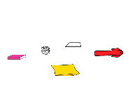  Grab some cushions, clothes or even pieces of paper to be the hippos, then lay them out across the floor. Make sure they're not too far apart.  2  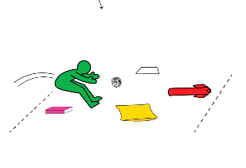  When you're ready, start your crossing! Crouch down like a frog and leap over the first hippo.  3  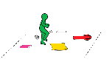  When you land back on the floor, keep hopping to stay out of the mud! Make your way across the mudhole, leapfrogging over the hippos until you reach the other side.  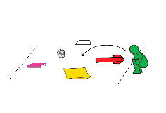  4  Once you've made it to the other side, turn around and cross back, leapfrogging the hippos again.  5  Keeping playing for 10 minutes, and invent different challenges for each crossing. You could time yourself to see how quickly you can make it across, try to cross making as few jumps as possible, or cross by jumping over every single hippo in the mud hole. Once you've finished, remember to recycle any paper hippos! | Be mindful – you could do every day to have a calm time focusing on your breathing and your thinking.  Sit down or lie down.  First take a take a deep breath in and breathe it out slowly – repeat 5 times. Get completely quiet and calm.  Mindful Safari (10-30 minutes)  Go on a search for nature and mini-beasts (mini-beast safari) in your garden.  Remain quiet, calm your thoughts and move slowly while on safari.  Turn your sense of sight, touch and sound onto high. Search for beautiful natural objects to explore. – What does it look like?  What colour is it?  What does it smell like?  Can I touch it?  What does it feel like?  Search for mini-beasts and other creatures that move. When you find a creature, watch the creature in silence for as long as you would like to.  What does it look like?  How does it move?  What colours can you see on its body?
Tuesday | Chris was afraid of the dark at first because he imagined all sorts of aliens, coming to get him.  How do you feel about the dark?  Imagine you are out at night in an area with no street lights – perhaps on a beach or in a wood. The sky is clear and stars are shining. The moon is high and spreading a pale light on tree tops or the sea. All else is dark – very dark.  Write words that would describe what you could see and hear as well as words that would describe how you feel.  EG  See- black sky, twinkling stars, pale moonlight, silhouettes of tree branches, shimmering water.  Hear – waves lapping gently, the wind rustling leaves, silence – no sounds.  Feel – inspired, in awe, small, excited, wondering, amazed.  Or – lonely, scared, frightened, lost, jumpy, anxious. | 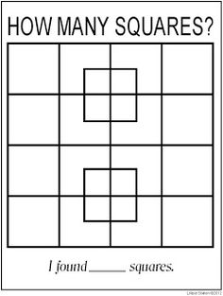  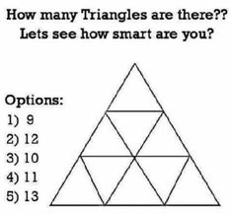  Make up your own how many _________ puzzle for someone else to have a go at. | Listen to and read along with this first part of a book about the moon.  https://video.link/w/ZoTlc  You only need to go as far as the fourth page but do read on if you are interested.  On the third page it talks about the fact that the moon has craters. These are caused by meteorites and asteroids and other space debris crashing into the moon. It does not have much of an atmosphere around it to protect it from this as the earth does.  Do an experiment to see how the holes are made on the surface of the moon.  You need 4 cups of flour and half a cup of baby oil. (cloud dough – behaves a little like sand)  Mix and put in a tray – or a round cake tin.  Take outside – or protect the floor and surrounding area. Drop small stones or pebbles into the flour mixture.  Watch how craters are formed. | Think of ways that you are able to relax.  Here are some things that people find relaxing  Laying or sitting looking at the clouds in the sky  Sitting quietly listening to natural sounds like birds singing or water bubbling  Singing  Reading a book  Having a bubbly bath  Playing with a pet – stroking their fur  Do some stretching  Exercise  Snuggle under a duvet or blankets  Breathing deeply  Playing a game  Chatting to a friend  Watching the TV  Can you think of other ways to relax to add to this list.  Choose 7 different relaxation activities to do and make a timetable saying which activity you will do on each day of the week to give yourself at least 10 minutes of relaxation.  E.G.  Monday – snuggle on the sofa  Tuesday – do some stretches  Wednesday – Go for a walk  Thursday – read  Friday – play a game  Saturday – have a bubble bath  Sunday – sit quietly and listen to nature
Wednesday | If you read the first part of the book ‘The Moon’ yesterday for your science work then write some facts that you found out about the moon.  If you did not read it yesterday, read it today or use the internet to find out some interesting facts about the moon.  Here is the link  https://video.link/w/ZoTlc | Draw 10 circles – planets!  Write the numbers 0 – 9, one number on each planet and the cut the planets out.  Decorate it you wish as long as you can still see the number.  First match the planets to show the numbers that add up to ten – the number bonds.  Choose a number under 10 and show how many ways you  can make it using your planet.  Eg to make 5 you could have 1 and 4 or 3 and 2.  Harder  Make yourself another set of planets as well with the 10s numbers on – 10 to 90  First make number bonds to 100 with the tens,  Then choose numbers under 100 and show as many ways to make the number using your planets as you can.  Eg  34  20 + 10 + 3 + 1  Or 30 + 4  0r (50 – 20) + (1 + 3)  Harder – make a number under 100 still but use multiplication and division in your calculation  34  (3 x 10) + ( 4 ÷ 1)  Or (20 + 40) + ( 8 x 1)  2 | Phases of the moon  You will have found out that the moon is a satellite of the earth and takes about 28 days to travel around the earth. It only has light when it is reflecting sunlight. As it travels round different amounts of light are reflected and the shape of the lit part changes.  This changing pattern of light is called the phases of the moon.  This is a useful video that shows why the moon has different phases  https://www.youtube.com/watch?v=f4ZHdzl6ZWg  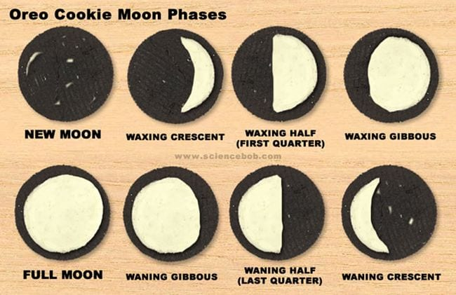  See if you can make the phases of the moon using Oreo biscuits or if you don’t have any of these you could draw them.  Science activities that you can eat - One of the favourites is the Oreo Cookie Moon Phases activity. It’s almost as if Oreo cookies were made for this lesson, and it’s a great way to learn how to match a moon phase name with a moon phase appearance.  You will need:  An Oreo cookie for each moon phase  A Popsicle stick or other tool for scraping the frosting  Carefully twist apart and scrape the cream off to look like the 8 phases of the moon.  Take a photo – then eat your lesson!  https://sciencebob.com/oreo-cookie-moon-phases/ | Go for a walk or out on your bike for some mid-week exercise.  Look up the sky – can you see the moon? It is sometimes visible in the day – usually early in the morning or late afternoon though.  Think about all the stars and planets that are up there, that by day you cannot see without a telescope.  Before you go to bed, have another look at the sky. If it is dark and a clear night you will see many stars and planets, that you could not see during the day.  Think about how amazing it is that the universe is so big and full of stars and planets – even during the day when they cannot be seen.
Thursday | What do you think it would be like to live on another planet?  Use your imagination to think what might be the same or different on another planet. These questions may help.  Would you need any special equipment to help you walk or breathe? Astronauts to the moon had to have weighted boots to help stop them floating away.  What would the surface of the planet be like – colour? Mountains? Craters? Volcanoes? lakes? Seas?  Would there be any plants or animals?  Would there be other creatures?  Aliens perhaps? What would they look like? Speak like?  Put all your ideas together and write a short description of life on your imaginary planet.  or  Draw a picture of it and write captions and labels on your picture to show what it is like. | We used to say there were 9 known planets but Pluto was downgraded to a dwarf planet so we now only count 8 planets.  We could write this as a number sentence  9 - 1 = 8  Choose 6 numbers and say what they become if you take one away.  Write the calculations you make as number sentences.  Harder  Choose larger numbers up to 100  Take 1 away from each to start with and then  Take away 10 from each  Harder still – choose 6 numbers up 1000  Take away 100 from each  Choose 6 numbers up 10,000  Take away 1000 from each.  Write number sentences for all the calculations you do. | Learn the order of the planets  There are 8 planets in our Solar System  Mercury (nearest the sun)  Venus  Earth  Mars  Jupiter  Saturn  Uranus  Neptune  Pluto used to be included in this list but it was downgraded from a major planet. It is now classed as a dwarf planet.  To learn the order, many people use a mnemonic. A sentence where each word begins with the same letter as the name of the planet.  For example:  Mercury My My  Venus Very Viscious  Earth Educated Earthworm  Mars Mother Might  Jupiter Just Just  Saturn Served Swallow  Uranus Us Us  Neptune Noodles Now  Try to make up your own mnemonic and find out something about each planet.  Here is a book about the planets from Seymour Simon to help you learn about the planets  https://video.link/w/VLtmc | Make a rocket or space shuttle out of an empty toilet roll middle and card  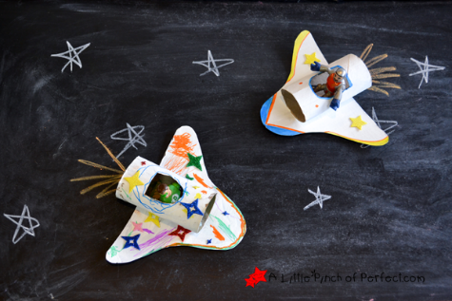  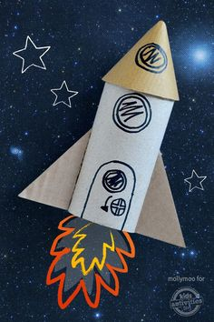  See below for instructions to make the space shuttle or watch  https://video.link/w/6Itmc  or just use your imagination.
Friday | Make as many words as you can from the words  atmosphere space  eg.  mass  moss  at  am | Practise your addition number bonds or times tables using the games on Top Marks.  Choose your age group and then choose the topic – counting, addition, times tables.  Then choose the game that will help you to practice the skill you need to work on. Eg Mental Maths Train game  https://www.topmarks.co.uk/mat hs-games/mental-maths-train | Use the picture ‘ Starry Night’ by Vincent Van Gogh to inspire your own starry night painting or picture.  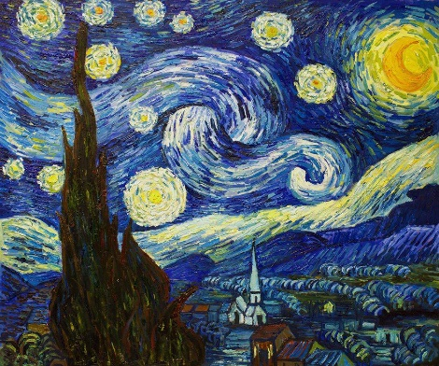  You could use wax crayons and a wash of paint as shown in the following link  https://www.youtube.com/watch?v=FLNU6dPi93s  There are other You-tube videos that show you how to put a Starry Night picture together on the internet that might help you too.  Or you could just do your own version of the painting using whatever colours you have. | Minute to win it  Set some minute challenges  How many can you do in a minute?  Hops  Star jumps  Push ups  Dried beans or peas can you pick up with chopsticks  Cards can you deal  Countries can you name  How far can you count to  How many boy’s names can you say  How many girl’s names can you say  How many times can you bounce a ball  How many times can you throw a ball up and catch it  Make up your own minute challenges too.  Repeat challenges and try to beat your own record each time.

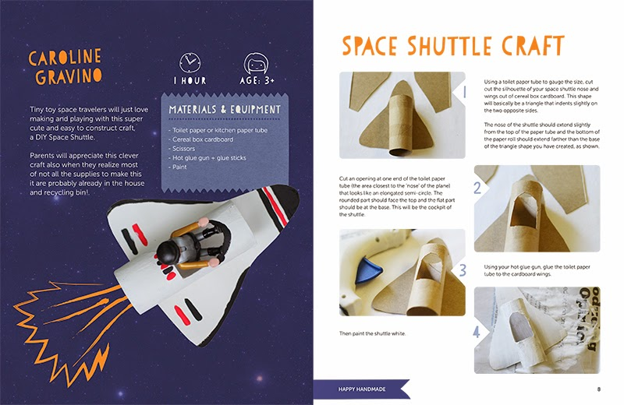

Additional Information/Useful Websites:
BBC bitesize daily lessons - BBC bitesize daily lessons. All sorts of interesting and engaging lessons covering all ages and subjects.
BBC Bitesize daily lesson now daily on CBBC from 9am each morning
https://pehubportal.co.uk/ - PE great ideas which require little or no equipment
https://www.thebodycoach.com/blog/pe-with-joe - Live workout with Joe Wicks on Monday Wednesday and Friday. Lots of past workouts on his YouTube channel too.
Change for life – lots of physical activities to do at home.
Times Tables Rock Stars – Multiplication table practice for years 1 -6
Maths Whizz – Maths Learning for years 1 - 6
I See Maths – video maths lessons for years 1 -6. A new Maths lesson will be shown every day.
White Rose Maths – online video lessons which support our school maths work – new lessons will be published each day
Extra White Rose from Amazon – some extra white Rose maths work delivered as an e-book but questions can be viewed and done on paper.
Maths Games – lots of maths games for maths practice.
https://readingeggs.co.uk/ - Reading Eggs
https://www.thenational.academy/ Lessons for all ages on all curriculum subjects
https://www.twinkl.co.uk/home-learning-hub - lots of activities and worksheets to print out, for all subjects and ages
Read Write Inc – daily phonics lessons

