East Stour Learning Activities w.b 22/03/21
Things to practice/do every day: Reading, exercise, phonics/spellings, times tables, number bonds.
This week’s activities have a local area and places theme
 | English | Maths | Topic | Daily Challenge
Monday | Look at the book’ Window’ by Jeannie Baker on  https://video.link/w/Zs6cc  It is a book without word that shows the view from the window of a house and how it changes over the years the baby grows up.  If you cannot access the book, have a good look out of one of the windows in your home.  Choose one of the window pictures. Write words and phrases to describe what you can see out of the window – you will have to stop the video at the picture you have chosen. ( or use the one below)  Or write words and phrases to describe what you can see out of your window.  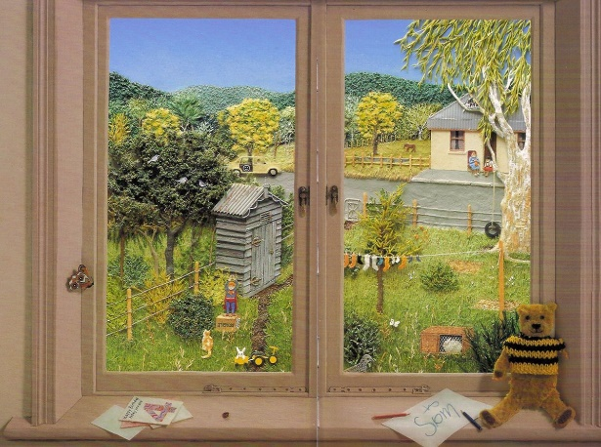  EG – tree, washing line, rabbit, fence, hill, shed……….. | The answer is  Easy 5  Medium 24  Harder 96  Hard 144  What is the question?  Write all the questions that could bring the answer | Draw a map of your route to school. If you live a long way from school, you might want to start nearer to school.  Remember when you draw a map you are looking from above.  Imagine you are a bird flying in the sky and looking down on you as you walk to school. It would only see the top of your head not your face!  It would be able to see all the roads leading to the school and the roof tops but not the sides of the houses.  See how many of the roads you can name.  If you find the map difficult, draw a picture of your house and practice writing your full address. It is important to know where you live!  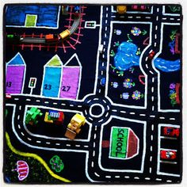 | Be mindful – you could do every day to have a calm time focusing on your breathing and your thinking.  Sit down or lie down.  First take a take a deep breath in and breathe it out slowly – repeat 5 times. Get completely quiet and calm.  Five Senses  Lie down or sit down in a comfortable position – perhaps in your garden if it is dry enough and the weather is fine. Get someone to call out the five senses one after the other giving about 15 seconds on each or call them out for yourself.  When each sense is called think only of the things you can notice about that sense.  Sight – what can you see? Hearing – what can you hear? Smell – what can you smell? Taste – is there anything you can taste?  Touch – what can you feel? (grass, carpet, wood floor, blanket etc)
Tuesday | Look at the words you wrote yesterday that showed what you could see in the picture or out of your own windows.  These could have been  trees  grass  fields  flowers  roads  walls  hills  cars  shops  Think of two adjectives to describe each thing you wrote yesterday  For example  Trees – tall, leafy  Grass – green, tufty  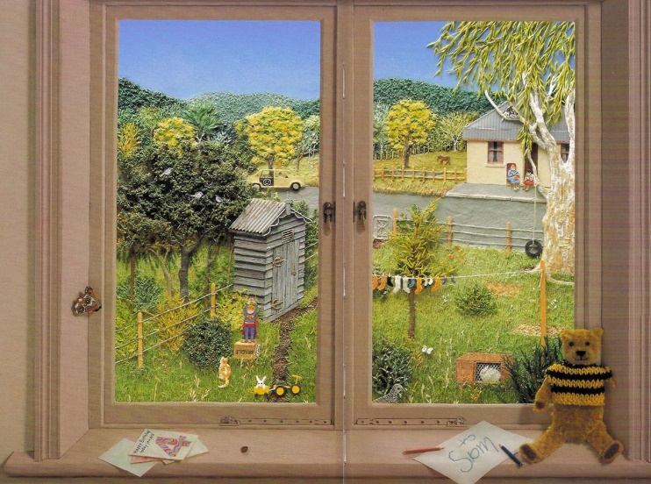 | 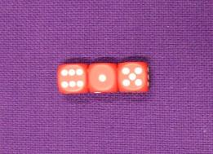  Take a look at some ordinary dice.  What do you notice about the way the numbers are arranged?  Now look at these three dice in a row:  The numbers on the tops of the dice read 6, 1 and 5.  What do the numbers on the top add up to?  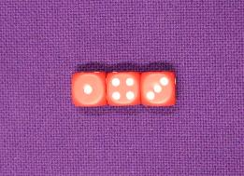  Can you use what you found out about the way the numbers are arranged to say what numbers are on the bottom of the dice? Were you correct?  What is the sum of the numbers on the bottoms of the dice?  Let's try that again.  This time the numbers on the top read 1, 4 and 3.  Can you work out the total?  Can you work out the numbers on the bottom and their total?  Try out some arrangements yourself. Each time record the sum of the numbers on the top and the sum of the numbers on the bottom.  Do you notice a relationship between the 'top sum' and the 'bottom sum'?  Can you explain it?  To make it easier use only two dice and roll them to find the two numbers on top that you have to add. | At the Zootropolis Police Academy, Judy has to prove she's got what it takes. Have you got the skills to pass this training test?  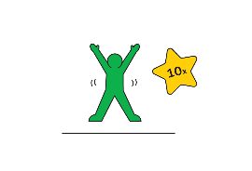  Stand to attention and start by doing 10 star jumps.  2  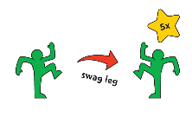  Now do 5 hops on your right leg, then 5 on your left.  3 Finish by running on the spot for 10 seconds and then salute.  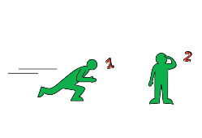  4  Repeat this again as fast as Judy would for 10 minutes, or make up your own moves. | Toilet Roll Middle Boules  You will need each player to have 3 balled up socks of the same colour and one toilet roll. Begin the game by throwing the toilet roll into any space, this could be the living room or garden. The objective of the game is to win by getting your socks closest to the toilet roll. Each player takes it in turns to throw to the toilet roll. To make it easier have the toilet roll closer, harder further away. This game is played best with 2 – 4 players.
Wednesday | Write a descriptive sentence about each thing you saw in the window picture or out of your window.  Use the words you have collected over the last 2 days to help.  For example  An ancient, gnarled tree stands in the garden with leafy, green branches pointing to the clear blue sky.  Brightly coloured socks flap vigorously on the single thin washing line.  A rickety, grey shed stands by the wood and wire fence.  A furry, white rabbit rests calmly in its small, enclosed hutch.  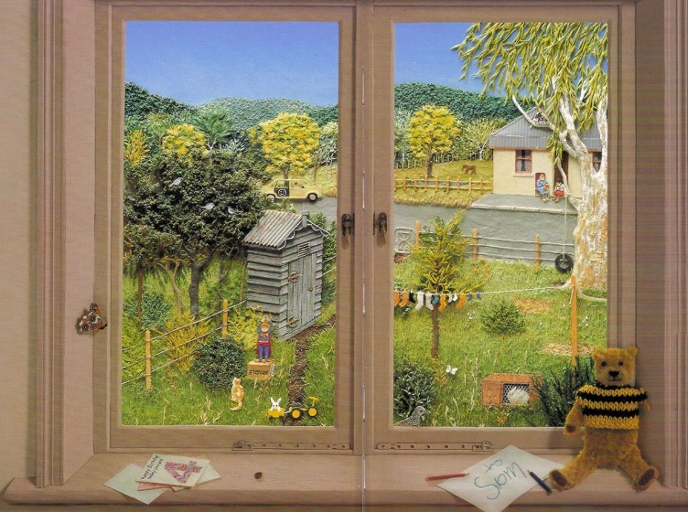 | 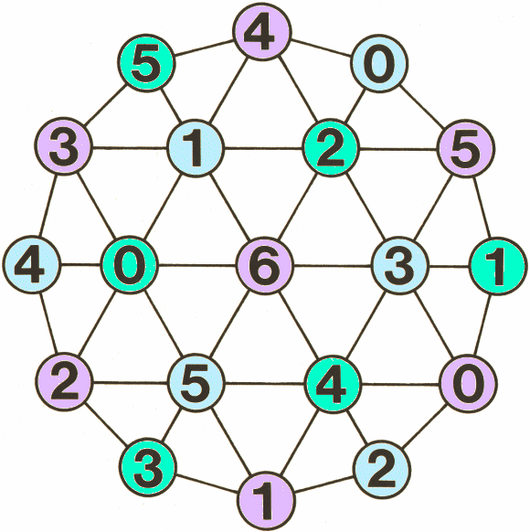  Use the grid above as a game board.  Choose a target to make  Eg 23  Player 1 puts a counter on one of the numbers say 4.  Subtract that number from the target number  Example 23 – 4 = 19  Either you or if you have someone to play with, the other player, moves the counter to another number – but it must be next to the first number moving along only one line to get to it. Say 5.  Then subtract this number. 19 – 5 =14  Player 1 moves it again say to 3 this time – subtract.  14 – 3 = 11.  You keep going until you reach 0 and the one who makes the move that brings you to zero is the winner. If you can’t get to zero it is a draw.  You need to think ahead to stop the other player winning and you making the target as winner.  If you play by yourself, you could see how few moves you need to make to reach the target.  Copy out the grid or print it from the end of this document. | We live in Ashford.  Make a list of all the places that you can go in Ashford to enjoy yourself, have fun, to do sport, have a picnic, watch something, buy things, relax or spend your leisure time – when you do not have to be at school and your adults are not working.  When you have thought of all the great places in Ashford where you can enjoy yourself, choose your favourite place and draw a picture of yourself there. | Go out for a walk.  As you walk look for these things in your local area  Tick off what you find or even better take a photo of each thing and make a local area document.  Can you find  A shop/ superstore  A school  A community hall  A business (not a shop)  or offices  A pub  A post office  A church  A bridge  A stream  A river  A field  A gate  A terraced house  A semi-detached house  A detached house  A garage  Flats  A post office  A car park  A lamppost  A letterbox  Double yellow lines  A garden  An allotment  A brick wall  A play park  Trees  A station/ railway line  Anything else that is always there – so not a cat because tomorrow that cat might be somewhere else
Thursday | Here are some words that are about places and natural features of the world.  Choose 10 of the words and make them into a picture dictionary.  Check you know what the word means in a dictionary.  Then draw it and write what its meaning is.  Then put the pictures into alphabetical order to make your dictionary.  river  mountain  shop  house  road  bridge  motorway  railway station  field  waterfall  cliff  beach  desert  iceberg  city  town  village  county  church  community hall  play park  football pitch | Plan a party  Decide on a budget for a party - £10, £20 or £50.  Next decide what things you want to have at the party – food, drink, party bags, hats …  Sandwiches X 10 £1.50  Sausage rolls x 10 40 p  Crisps X 2 big packets £1  Cake x 1 £2.50  Small cakes x 10 £1.20  Chocolate bars x 10 95p  Cherry tomatoes x 10 85p  Cheese cubes x 10 60p  Lemonade X 2 bottles £1.50  Cola x 2 bottles £ 1.50  Party bags x 10 75p  Party hats x 10 20p  Make a list of all the thigs you could have for the party and add them up to make sure you have stayed within your budget.  Easier – give some prices in pence for some items and choose some to add together and perhaps find the right coins to pay for them. | Ashford is in a county called Kent.  Kent is a county in England.  England is part of the UK (United Kingdom) along with Scotland, Wales and Northern Ireland.  London is the capital city of England and the United Kingdom.  Try to find out the names of some other counties in England.  Find ten interesting facts about London either online or by asking your adults.  Here are a couple of links for videos to help. ( If you are on Seesaw you will have to copy and paste)  https://www.youtube.com/watch?v=HrJNIUp2izQ  https://video.link/w/uQ0cc | Make a model of your house or even your street or local area!  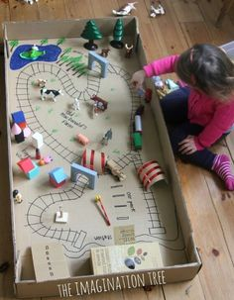  This picture is a railway but you could make if rods instead.
Friday | Make as many words as you can from the letters in the words Capital London.  C A P I T A L L O N D O N  For example  pit  pail | Practise your addition number bonds or times tables using the games on Top Marks.  Choose your age group and then choose the topic – counting, addition, times tables.  Then choose the game that will help you to practice the skill you need to work on.  Eg Mental Maths Train game  https://www.topmarks.co.uk/maths-games/mental-maths-train | Play the game ‘On the bank and in the river’  Lay down a skipping rope as a line or some other rope, string or wool.  Decide which side is the bank and which side is the river. Start standing on the bank.  Ask someone to call the instructions. They say  either  On the bank or  In the river  Jump to the position they say but watch out they may say the same one twice to catch you out.  Place Obstacle Course  Lay a course out with obstacles to run round – make the obstacles names of places in Ashford or London and thensome one could say instructions of what order to go to each obstacle  Eg  Station  Imagine  Asda  Motorway  School  Outlet  River  Then change the order you visit the obstacles, running from one place to the next. | Make a Lava Lamp  - Materials A clean plastic bottle, try to use one with smooth sides  - water  - Vegetable Oil (or you could use Mineral or Baby Oil instead)  - Fizzing tablets (such as Alka Seltzer)  - Food Colouring  Instructions Fill the bottle up about 1/4th (1 quarter) with water.  Pour the vegetable oil in the bottle until is almost full. You may want to use a measuring cup with a spout or a funnel. You may have to wait a couple of minutes for the oil and water to separate.  - Add a few drops of your favourite food colouring.  - Watch as the colour sinks through the oil.  - Did your drops of colour mix with the water immediately or float in between for a few minutes?  - Break your fizzy tablet in half and drop part of it into the bottle. Get ready … here come the bubbly blobs!  - You can even get a flashlight, turn off the lights and drop in another half tablet. This time shine the flashlight through the lava lamp while the blobs are bubbling!

Additional Information/Useful Websites:
BBC bitesize daily lessons - BBC bitesize daily lessons. All sorts of interesting and engaging lessons covering all ages and subjects.
BBC Bitesize daily lesson now daily on CBBC from 9am each morning
https://pehubportal.co.uk/ - PE great ideas which require little or no equipment
https://www.thebodycoach.com/blog/pe-with-joe - Live workout with Joe Wicks on Monday Wednesday and Friday. Lots of past workouts on his YouTube channel too.
Change for life – lots of physical activities to do at home.
Times Tables Rock Stars – Multiplication table practice for years 1 -6
Maths Whizz – Maths Learning for years 1 - 6
I See Maths – video maths lessons for years 1 -6. A new Maths lesson will be shown every day.
White Rose Maths – online video lessons which support our school maths work – new lessons will be published each day
Extra White Rose from Amazon – some extra white Rose maths work delivered as an e-book but questions can be viewed and done on paper.
Maths Games – lots of maths games for maths practice.
https://readingeggs.co.uk/ - Reading Eggs
https://www.thenational.academy/ Lessons for all ages on all curriculum subjects
https://www.twinkl.co.uk/home-learning-hub - lots of activities and worksheets to print out, for all subjects and ages
Read Write Inc – daily phonics lessons

