East Stour Learning Activities w.b 04/05/21
Things to practice/do every day: Reading, exercise, phonics/spellings, times tables, number bonds.
This week’s activities have a ‘seaside’ theme
 | English | Maths | Topic | Daily Challenge
Tuesday | Write an acrostic poem about the seaside.  Today collect words for you to use when you write tomorrow.  On paper draw a table with two columns. Put nouns and the top of the first column and adjectives at the top of the second.  Think of as many things as you can that you would find at the seaside in the nouns column and then think of great adjectives to describe the things you though of. Put those in the adjectives column.  eg.  Nouns Adjectives  Crabs Starfish Bucket Spade Sand Sunshine Rocks sea Orange,crusty Pointed Plastic Sharp, shiny,red Silky, shimmering Brilliant, dazzling Rugged, rough Sparkling, rippling | Draw and name as many 2D shapes as you can.  Create some seaside pictures using 2D shapes.  A sand castle with a flag  A kite flying on the beach  A beach ball  A boat | Practice skipping with a rope.  How many skips can you do in a minute?  Try to beat you score.  How many skips can you do before you have to stop?  Can you run and skip at the same time?  If there I more of you, con you skip together in the rope?  Can you skip backwards?  Can you do any skipping tricks? | Be mindful – you could do every day to have a calm time focusing on your breathing and your thinking.  Sit down or lie down.  First take a take a deep breath in and breathe it out slowly – repeat 5 times. Get completely quiet and calm.  Ocean Breathing  Lie down or sit in a comfortable position.  Slowly breathe in, then breathe out through pursed lips as if blowing out through a straw.  This sounds like the waves drawing back then crashing on the sea shore.  Carry on breathing like this, making the sound of the ocean waves, for at least one minute.
Wednesday | Use the words you collected to write an acrostic poem.  Write the letters that begin seaside down the side of your paper.  Think of a word or sentence that starts with each letter to do with the seaside.  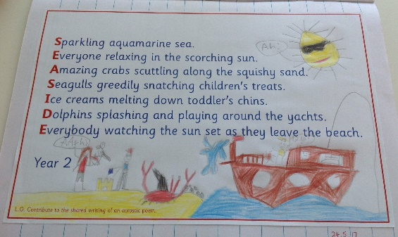  S  E  A  S  I  D  E  Sparkling aquamarine sea  Everyone relaxing in the scorching sun  Amazing crabs scuttling along the squishy sand  Seagulls greedily snatching children’s treats  Ice creams melting down toddler’s chins  Dolphins splashing and playing around the yachts  Everybody watching as the sun sets as they leave the beach | Ice cream mix ups  You have a double ice cream cone and two flavours of ice-cream – vanilla and chocolate.  How many different ice creams can you make – 2 scoops only!  You could have – Double chocolate, double vanilla or one scoop of chocolate and one scoop of vanilla.  The answer is 3 different ice creams.  Now add strawberry into the selection.  How many different ice-creams could have now?  It might help you to draw picture – or use 3 colours of blocks or counters to represent your ice-cream scoops.  What about if there were a fourth  flavour to choose? Mint.  How many now? | 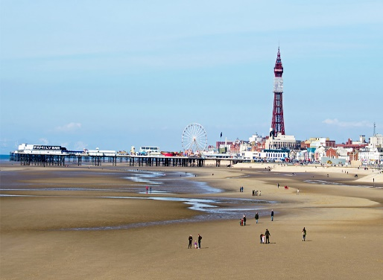  This is Blackpool beach. Blackpool is a very popular seaside resort.  See if you can find where it is on a map – it is not very near to Ashford so try looking on the coast to the North-West.  If you put Blackpool in the Google maps search, it will find it for you.  This is the Pleasure beach at Blackpool with a large roller coaster called ‘The Big One’ and lots of other rides and activities.  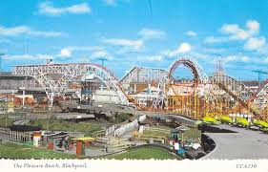  Find out what else there is at Blackpool and think about and write why people might like to come here for a seaside holiday.  http://letsgowiththechildren.co.uk/places-to-go/blackpool/ | If you were going on holiday to the seaside what would you take with you?  Draw a suitcase and draw the clothes you would take with you.  Perhaps you would need other things for your holiday too – don’t forget to pack them in your case e.g. teddy, camera. notebook, reading book, game
Thursday | Listen to and read  Duffy’s Lucky Escape by  Ellie Jackson  https://video.link/w/tP4oc  This story highlights the problem of our plastic rubbish making its way into the sea and then causing harm to animals.  What kind of animal is Duffy?  How is she swept away from where she normally feeds?  What does she eat instead of her proper diet of jellyfish and octopus.  How does that make her feel?  Why can’t she swim down to the sea grass?  Who rescues her?  How do they make her better?  What happens in the end?  Do you think this is a good thing or a bad thing?  What can you try to do to help make sure this doesn’t happen to another creature? | How many different types of plastic do you use in a day (or a week) or have in your house?  Carry out a survey to record this information.  Look round your house and see what things are made of plastic or have plastic parts on them.  You could record these in groups  Groups Tally Total  Toys  Packaging for food  Cleaning tools  Furniture  Eating and cooking utensils  Bottles  Make tally marks - a line for each one till you get to 5 and then cross the 4 lines to show a group of 5 like a little gate.  Or you could record by room – how many items in the kitchen, lounge, bedroom etc.  May be you just want to look at food packaging and record types– plastic bags, plastic trays, plastic vacuum packaging, bottles etc  Harder  When you have collected the information about plastic in your home, make a pictogram or bar chart to show what you found out.  For a pictogram use a picture – like a bottle for example to represent each piece of plastic found or if you have lots, each bottle might represent 4 pieces of plastic found. | Before we had clocks and watches people used sundials to mark the passing of time.  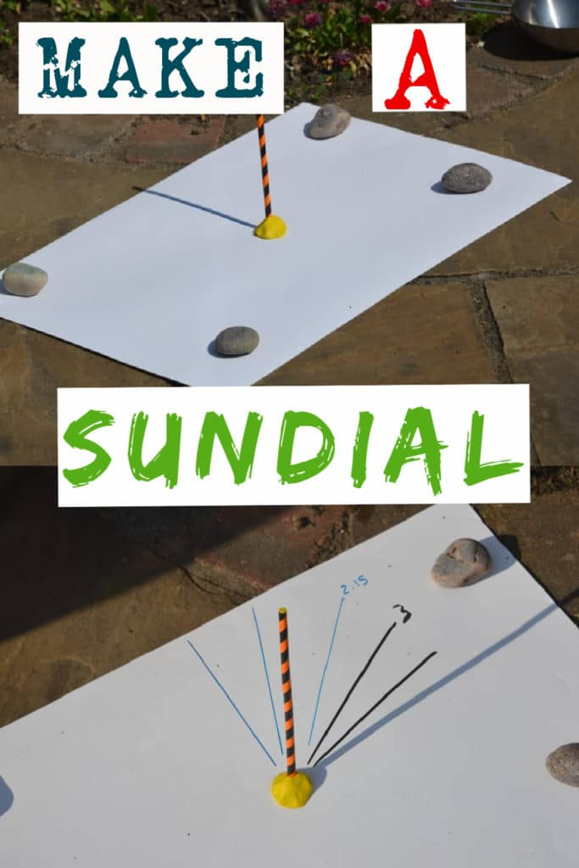  A sundial measures time by the position of the sun and usually has markings for each hour of sunlight. Sundials have something in the centre which casts a shadow over the markings showing what the time is. There are lots of ways to make a simple sundial, you can draw around your shadow from the same central point at different times throughout the day, use stones or even just a simple straw or stick like this.  All you need is a piece of paper, some stones to hold it down, plasticene or blutak to hold the straw/stick in place and a sunny spot outside.  Place the paper in the sunny spot and fold down with stones around the outside.  Place the straw or stick in the centre of the paper and secure with plasticene or blutak.  Then go out regularly to mark the time. Use coloured pens and a ruler to draw a line where the shadow is and mark on the time when you did it.  Here the recording started at noon at 12 noon and they watched as the shadow of the straw changed over the afternoon, marking every hour. They were a bit late with one of our readings as you can see.  https://www.science-sparks.com/how-to-make-a-sundial/  or try this one  https://www.kcedventures.com/blog/how-to-make-a-sundial-for-kids | 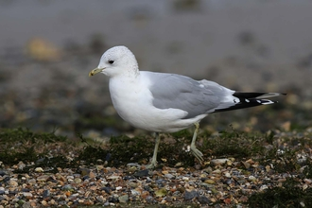  Go for a walk and count how many sea birds you spot. Even though Ashford is not by the sea, gulls can be seen. They come inland to look for food.  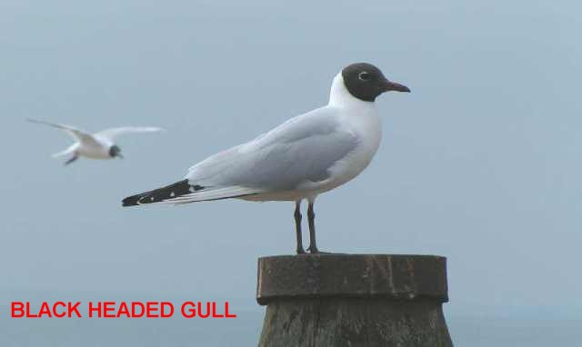
Friday | Make as many words as you can from the letters in these words  Seaside adventure  eg.  Vent  Side  sure  at  as | Practise your addition number bonds or times tables using the games on Top Marks.  Choose your age group and then choose the topic – counting, addition, times tables.  Then choose the game that will help you to practice the skill you need to work on. Eg Mental Maths Train game  https://www.topmarks.co.uk/mat hs-games/mental-maths-train | Watch this short video of creatures you might find in a rock pool at the beach.  https://www.bbc.co.uk/bitesize/clips/zf3ygk7  Investigate one of the creatures you see a bit further using the internet or find out about other creatures that can be found in a rock pool.  Draw a picture of your chosen creature/creatures? Write short notes about what you found out. | If you were going on a holiday to the seaside what things would you want to do?  Draw or write about all the things you would do.  Some ideas  Swim, paddle, build sandcastles, sunbathe, play with a ball or Frisbee, eat ice-cream, go on rides, play crazy golf, go on trampolines, search rock pools, go in a boat,  eat fish and chips, go to the amusement arcades, go on the pier, visit a zoo or aquarium, go on a cliff railway.

Additional Information/Useful Websites:
BBC bitesize daily lessons - BBC bitesize daily lessons. All sorts of interesting and engaging lessons covering all ages and subjects.
https://pehubportal.co.uk/ - PE great ideas which require little or no equipment
https://www.thebodycoach.com/blog/pe-with-joe - Live workout with Joe Wicks on Monday Wednesday and Friday. Lots of past workouts on his YouTube channel too.
Change for life – lots of physical activities to do at home.
Times Tables Rock Stars – Multiplication table practice for years 1 -6
Maths Whizz – Maths Learning for years 1 - 6
I See Maths – video maths lessons for years 1 -6. A new Maths lesson will be shown every day.
White Rose Maths – online video lessons which support our school maths work – new lessons will be published each day
Extra White Rose from Amazon – some extra white Rose maths work delivered as an e-book but questions can be viewed and done on paper.
Maths Games – lots of maths games for maths practice.
https://readingeggs.co.uk/ - Reading Eggs
https://www.thenational.academy/ Lessons for all ages on all curriculum subjects
https://www.twinkl.co.uk/home-learning-hub - lots of activities and worksheets to print out, for all subjects and ages
Read Write Inc – daily phonics lessons

