Tubas & Trombones

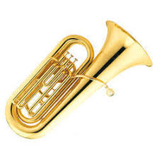
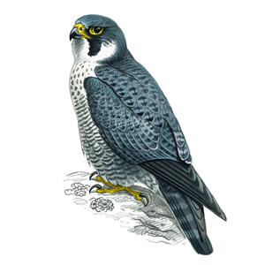

English
The children will be continuing with Literacy or RWI lessons this term. Our book for this term is Major Glad, Major Dizzy. We will be exploring the book, doing lots of activities and writing around this.
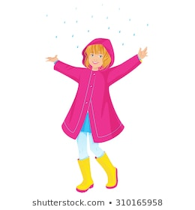
Coats and wellies
As the weather remains cold and unpredictable please could you ensure that your child comes to school in a suitable jumper, coat and footwear and please name these. Wellies are needed as our playground gets muddy. We also have the opportunity to go to forest school too with boots on!

MANY THANKS FOR YOUR CONTINING SUPPORT WITH HEARING YOUR CHILD READ AT HOME. IT CAN HAVE SUCH A POSITIVE EFFECT ON CHILDREN’S PROGRESS.

Hello!
Welcome to our newsletter for Term 4. We are looking forward to an exciting term 4. If you have any queries please contact us through class charts.

Numeracy
This term we are going to be consolidating our knowledge of the 2, 5 and 10 times tables. We will also be exploring length and height.
Science
This term we will be focusing on inventors, linking to our topic work we will be exploring inventors of the Victorian era and carrying out some experiments to explore these.

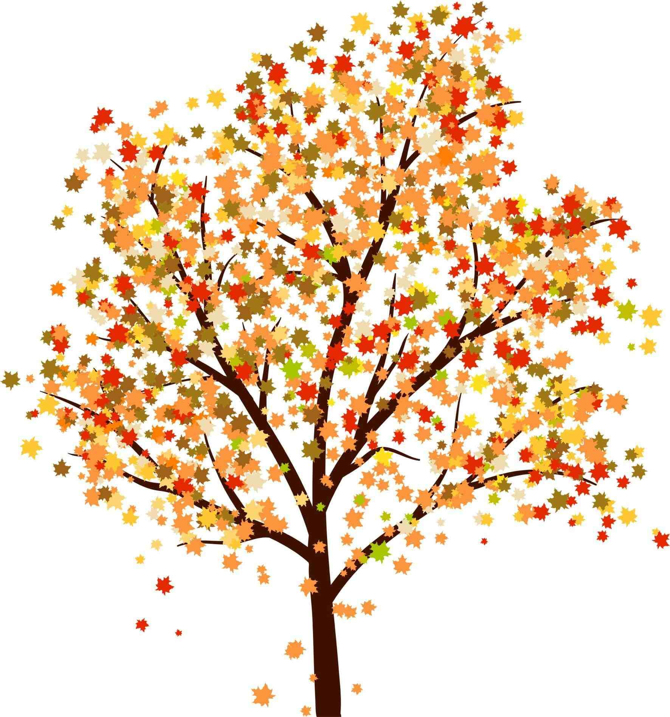
PE
We have 2 PE slots each week. Tubas and Trombones both need to come in PE kit on Tuesday and trainers or plimsols with school uniform on Fridays. This term we will be focusing on ball skills.

History
We will be doing lots of work this term around the past and now, looking at how things have changed over time, we will be researching events that happened and carrying out research about Mary Anning and fossils.

If you have a computer, a good website for numeracy and literacy games is www.ictgames.com

Reading
The children will be bringing home a book every Friday that is linked to their reading level. Please could you hear your child read this book at least 4 times during the week and ask your child questions about the book to check their understanding of the book. (This will promote fluency) The reading book and yellow reading record then needs to be returned the following Friday. You can of course include books from your home bookshelf in the reading record.
Homework
We will continue to send homework on Fridays Homework will be a set of spellings together with an activity to help the children to remember them, and a piece of maths/times tables. Spelling Homework will be set on EdShed and Maths homework will be shared through Tapestry.

Topic
Our topic for this term is Time Travellers, we will be exploring the differences between the past and present and exploring what life was like back then!

Parents Evening
Parents evening is on Tuesday 27th March and Thursday 29th March. Please contact the office if you haven’t received communication about this.

Book Week
Book week is w/c 4th March, we will be exploring different books and authors throughout the week and exploring which books children like and dislike. We will be dressing up on Thursday 7th March this year. There will be a book sale after school from 23rd – 29th February, in the hall from 3pm for you to have an opportunity to purchase books.

Please ensure your child has a named water bottle, jumper and coat every day and that all clothing is named. Bottles should contain water only according to our school policy



