**Our value this term is EMPOWERED**



**For Term 2, our topic is**

**Endangered and Extinct!**

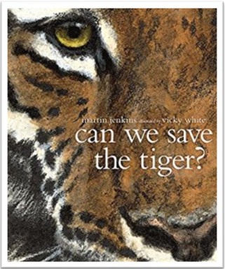

**Banjos and Double Basses**

**Information Leaflet Term 2**

**ENGLISH**—Each term we look at two books: one for reading and one for writing. During guided reading this term, by reading ‘Into the Jungle’ we will be working on our key reading skills to understand this text. In English, we will read ‘Can We Save the Tiger?’, using it to inspire a persuasive speech, a hybrid text, as well as poetry, before finishing with a Christmas WW1 letter.

**MATHS** – We will start this term by starting unit of work on Fractions. Year 6 will be taught to find equivalent fractions - including simplifying them, adding and subtracting fractions and mixed numbers. We will end our fraction work with multiplying and dividing fractions, and finding fractions of amounts. Furthermore, each week, children will complete half or full arithmetic papers.

**SCIENCE –** Science this term is all about scientists and inventors.

**ART –** This half term, we will be developing their sketching skills. The children will be taught how to use different sketching pencils and drawing techniques (scumbling, hatching, cross hatching) thinking about line, tone and texture. Then they will be applying these skills to sketch the Cenotaph during our trip to the Ashford Memorial Gardens.

**DT –** In DT, we will be exploring how food plays a part in celebrations and festivals. This will lead us then onto developing our own ideas towards making our own tear and share bread product that we can share with our families during an important celebration or festival.

**PE –** This term we will be learning the skills and techniques associated with Netball and Gymnastics. Children will develop their ability to apply netball knowledge and skills more strategically in competitive games. In Gymnastics, the children will learn how mount and dismount from apparatus as well as creating and performing sequences. **PE DAY is THURSDAY!**

**PSHE –** In PSHE this term, we will be focusing on a few very important topics, we will be spending the beginning of the term looking at how important it is to have a positive view of ourselves and finishing the term looking at what a healthy relationship looks like. We will also be spending a week looking at understanding Autism and how it affects those around us.

**HISTORY –** For History, we will be exploring key British historical figures across the decades by investigating those who are on past and present £10 notes.

**FRENCH –** In our French lessons, children will be continuing their learning how to tell the time in French and revising and applying our conversational skills; as well as learning all about French schools including places around the school, subjects and apply all this to a school timetable.

**MUSIC –** We will be listening to jazz and blues songs, learning how to play tunes on chime bars and improvise our own blues song using musical notes.

**COMPUTING –** This term, pupils willbe taught to select, use and combine a variety of software on a range of digital devices to design and create content that accomplish given goals, including collecting, analysing, evaluating and presenting data and information.

**R.E**. — In RE, children will be exploring the question: ‘How significant is it that Mary was Jesus’ Mother?’

**HOMEWORK:**

**READING –** Children need to read every day which also needs to be recorded in their reading record and signed by a parent or guardian. Children are expected to bring reading records in every day.

**SPELLINGS & TIMES TABLES -** Spellings are set weekly on Spelling Shed and times tables should be practised at home using any method that helps your child learn them (e.g. any online game, including Purple Mash).

**ATOM LEARNING -** Two pieces of homework will be set via our online learning platform.

All your child’s logins can be found in their reading record book.